[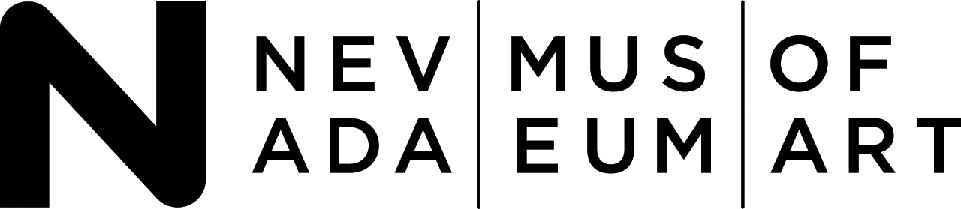](http://www.nevadaart.org/)

Donald W. Reynolds Center for the Visual Arts

E. L. Wiegand Gallery

160 West Liberty Street, Reno NV 89501

Become a Fan on [Facebook](http://www.facebook.com/pages/Reno-NV/Nevada-Museum-of-Art/11134676804)

Join the conversation on [Twitter](http://twitter.com/nevadaart)

Follow us on [Instagram](https://www.instagram.com/nevadaart/)

MEDIA CONTACTS:

Amy Oppio, COO/ Deputy Director

amy.oppio@nevadaart.org

Tommy Napier, Polskin Arts & Communications Counselors

tommy.napier@finnpartners.com

Apsara DiQuinzio Is Appointed Senior Curator of Contemporary Art at Nevada Museum of Art

Long Serving Curator Ann M. Wolfe Is Promoted to Chief Curator and Associate Director

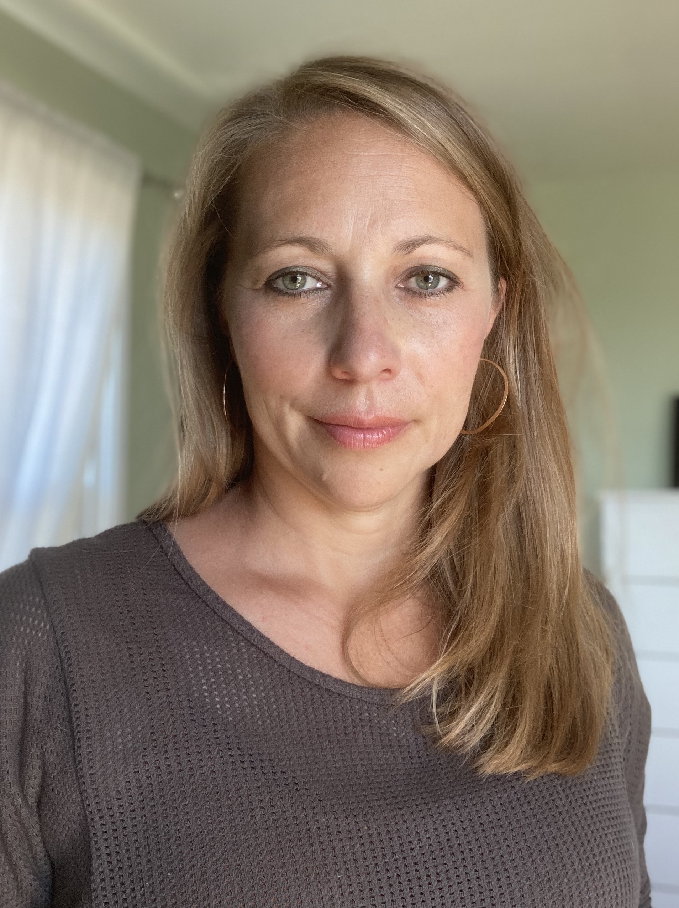

RENO, NV, August 26, 2021 – The Nevada Museum of Art in Reno, Nevada, today announced the appointment of the trailblazing art historian and curator Apsara DiQuinzio as the Senior Curator of Contemporary Art, effective November 1, 2021. DiQuinzio will conceive and realize exhibitions, produce original scholarship, and guide the Museum in strategic decision-making for contemporary art acquisitions. The Museum’s curatorial department will be under the direction of Ann M. Wolfe, who has been promoted to Andrea and John C. Deane Family Chief Curator and Associate Director.

David B. Walker, CEO, Nevada Museum of Art, said, “Apsara DiQuinzio has established herself as a national leader among curators, considering art as a catalyst for civic engagement and discourse. We are thrilled that she is bringing her keen eye, public spirit, and critical acumen to our curatorial team particularly now during a time of significant institutional expansion.”

Apsara DiQuinzio said, “I am delighted to assume the role of Senior Curator of Contemporary Art at the Nevada Museum of Art, and honored to be working with David Walker, Ann Wolfe, William L. Fox, and the entire team, as the Museum continues to expand upon its artistic and cultural programs. I look forward to getting to know the diverse communities of Reno and the greater Nevada region and to the work we will all do together. I am particularly inspired by the Museum’s dedication to its Indigenous communities and its focus on art and the environment.”

DiQuinzio joined the Berkeley Art Museum & Pacific Film Archive curatorial staff in 2012 and was promoted to senior curator in 2017. In that capacity, she oversaw large-scale exhibitions and also held the title of Phyllis C. Wattis MATRIX Curator, overseeing all aspects of the exhibition series that since 1978 has introduced new, cutting-edge art to the San Francisco Bay area. Her eagerly awaited exhibition *New Time: Art & Feminisms in the Twenty-First Century* opens at BAMPFA on August 28, 2021, offering an expansive survey of contemporary feminist art. The exhibition is presented as part of the Feminist Art Coalition (FAC), which was conceived by DiQuinzio in early 2017 as a platform fostering collaborations among arts institutions that aim to make public their commitment to social justice and structural change.

Previously, DiQuinzio served as Assistant Curator, Painting and Sculpture at the San Francisco Museum of Modern Art, and as a Senior Curatorial Assistant at the Whitney Museum of American Art. She holds a Master of Arts degree in Modern Art History, Theory & Criticism from The School of the Art Institute of Chicago and a Bachelor of Arts degree in Art & Art History, cum laude, from Colgate University.

During her tenure at BAMPFA, DiQuinzio curated the first survey exhibition in the San Francisco Bay area in twenty-five years of work by Ron Nagle, the first full-scale retrospective of work by Harvey Quaytman, and the first survey of work by Charles Howard since 1956. As part of the MATRIX series, DiQuinzio has organized solo exhibitions for Nicole Eisenman, Zarouhie Abdalian, Linda Stark, Will Rogan, Paz Errázuriz, Anna Maria Maiolino, Geta Bratescu, John Zurier, Eric Baudelaire, Will Brown, Tarek Atoui, Otobong Nkanga, Cecilia Edefalk, Pat O’Neill, Michael Armitage, Veronica De Jesus, Jay Heikes, Alicia McCarthy and Ruby Neri, Christina Quarles, Arthur Jafa, Kader Attia, *Orbits of Known and Unknown Objects: SFAI Histories*, and forthcoming exhibitions of work by Jumana Manna and Hannah Levy.

DiQuinzio enters a curatorial department under the direction of Ann M. Wolfe, who joined the Nevada Museum of Art in 2006 and has organized numerous exhibitions and authored numerous books. Wolfe specializes in photography, art and environment, contemporary Indigenous art of the Great Basin, and placing Nevada art and culture within a broader global context. Past exhibition and publication highlights include *Gianfranco Gorgoni: Land Art Photographs* (2021: Monacelli); Anne *Brigman: A Visionary in Modern Photography* (2018: Rizzoli Electa); *Tahoe: A Visual History* (2015: Skira Rizzoli); *Lita Albuquerque: Stellar Axis* (Skira Rizzoli, 2014); *The Altered Landscape: Photographs of a Changing Environment* (2011: Skira Rizzoli); and *Suburban Escape: The Art of California Sprawl* (2006: Center for American Places). Wolfe holds a graduate degree from the University of Southern California and an undergraduate degree from Santa Clara University.

**About the Nevada Museum of Art**

**The Nevada Museum of Art** is the only art museum in Nevada accredited by the American Alliance of Museums (AAM). A private, nonprofit organization founded in 1931, the statewide institution is supported by its membership as well as sponsorships, gifts and grants. Through its permanent collections, original exhibitions and programming, and E.L. Cord Museum School, the Nevada Museum of Art provides meaningful opportunities for people to engage with a range of art and education experiences. The Museum’s **Center for Art + Environment** is an internationally recognized research center dedicated to supporting the practice, study, and awareness of creative interactions between people and their environments. The Center houses unique archive materials from more than 1,500 artists working on all seven continents, including Cape Farewell, Michael Heizer, Walter de Maria, Lita Albuquerque, Burning Man, the Center for Land Use Interpretation, Great Basin Native Artists Archive, Ugo Rondinone’s Seven Magic Mountains, and Trevor Paglen’s Orbital Reflector. Learn more at [nevadaart.org.](http://www.nevadaart.org/)

The Nevada Museum of Art is located in the Great Basin on the occupied territories of Indigenous people. The state of Nevada consists of 27 federally recognized tribes from four nations: the *Numu* (Northern Paiute), *Newe* (Western Shoshone), *Wa She Shu* (Washoe), and *Nuwu* (Southern Paiute).

*Image:* Apsara DiQuinzio

###